**for the top Navigation Menu (Header Menu) of our Voilà Vélo website. I’ve broken it down step-by-step for clarity:**

**1. Navigation Menu Items (Main Menu)**

**The top menu should include the following items in this order:**

**Home (contains** Why choose our Voilà Vélo workshop?)

* **About**
* **Packages *(with drop-down menu)***

**1. La petite Koki**

**2.Pop Solo**

**3. Double fun**

**4. Ready set blend**

**5. Defi Parent enfant**

**6. La Smoothie Parade**

**7.Signature Package**

* **Events (with drop down menu)**
* **Corporate**
* **Openings & Activations**
* **Schools, Non-Profits & Birthdays**
* **Conferences & Expos**
* **How It Works (with drop-down menu)**
* **Build Your Event**
* **FAQ**
* **Contact**
* **Book**

**I’ve provideed the content and structure for each page or menu item in the next steps in English, and kindly translate it to French.**

**About**

Who we are

We’re Leen and Micha — two sisters with a big love for nature, healthy living, and biking. That’s how Voilà Vélo Fruité came to life — a joyful concept where people of all ages can hop on a smoothie bike, pedal their hearts out, and create their own delicious drink, powered entirely by their energy!

We believe in spreading positivity, promoting wellness, and getting everyone involved — no matter how young or old. Whether it's at a school event, a festival, or a corporate gathering, Voilà Vélo brings fun, flavor, and feel-good vibes to every occasion.

Our mission

Our mission is to make healthy living fun, simple, and inspiring. By combining motion, sustainability, and nutrition, we aim to spark awareness while creating happy, tasty memories.

We believe that one pedal stroke is all it takes to reconnect with your body, nature, and each other — and Voilà Vélo is here to make that happen.

Our Value:

**Health & Wellness**  
We believe that nourishing your body should be both delicious and enjoyable.

**Sustainability**  
We are committed to supporting local producers and practicing eco-friendly methods.

**Community**  
We foster connection and joy by bringing people together through our smoothie experiences.

**Empowerment & Inclusion**  
We inspire people of all ages and backgrounds to participate, create, and feel energized — because everyone deserves to be part of the fun and positive change.

**Packages: I’ve attached a photo for each package**

* + - 1. **Petite Koki Package**

**Kids’ all-time favorite!**  
Perfect for birthdays, daycare graduations, or family festivals, this package brings fun, laughter, and tasty smoothies to any celebration!

Two options to fit your needs:

* **Option 1:** 25 delicious smoothies + 1 hour of high-energy entertainment
* **Option 2:** 50 delicious smoothies + 2 hours of high-energy entertainment

**Package includes:**

* 1 child-friendly blender bike (ages 5–10) — they pedal, they blend, they have a blast!
* Fresh and colorful smoothies — made on-site with joy and energy
* Lively entertainment — music and a festive vibe everyone will remember

**Blended by Your kids, Powered by Fun!**

**We can personalize this package with custom branding, balloons, and decorations — just let us know!**

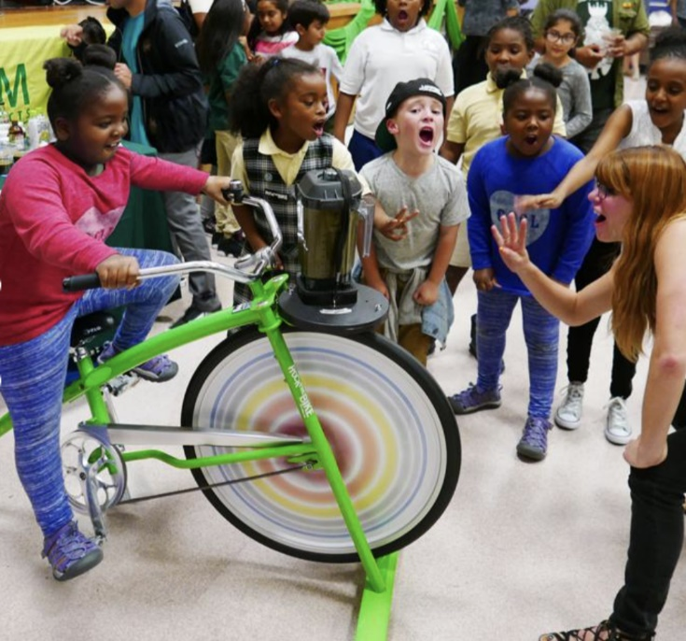

**2. Pop Solo package:**

**A guaranteed hit with teens, adults, and families!**  
Perfect for school events, office parties, or any festive gathering focused on health and fun!

Two options to choose from:

* **Option 1:** 50 smoothies + 1.5 hours of high-energy fun
* **Option 2:** 75 smoothies + 2.5 hours of high-energy fun

**Package includes:**

* 1 adult-friendly blender bike
* Fresh smoothies made on-site
* Fun-filled atmosphere with music and good vibes

**Blended by You, Powered by Fun!**

We can personalize this package with custom branding, balloons, and decorations — Contact us for more details!

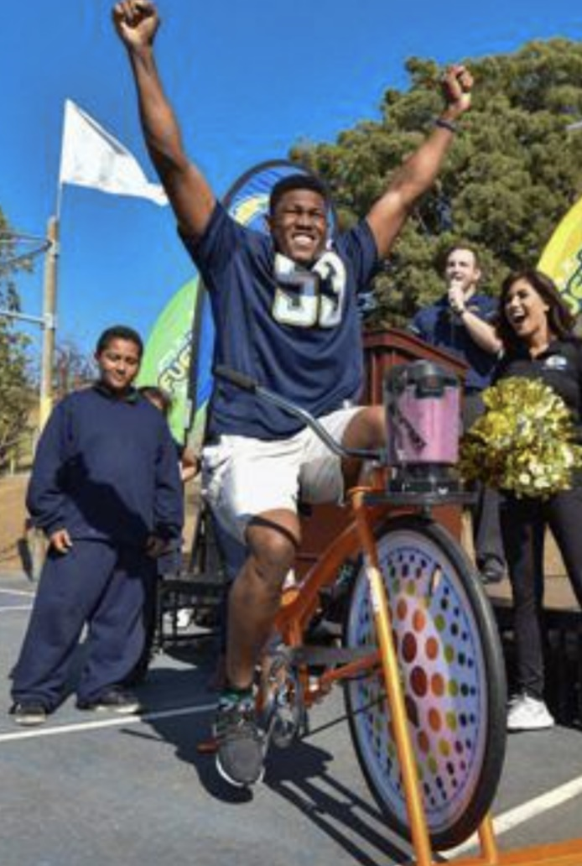

**3. Double Fun Package**

**Twice the bikes = twice the energy!**  
Perfect for:  
Community festivals, brand activations, fundraisers, corporate parties, open houses, and more!

Choose from 3 options:

* **Option 1:** 100 smoothies + 2 hours of entertainment
* **Option 2:** 200 smoothies + 3 hours
* **Option 3:** 300 smoothies + 4 hours

**Package includes:**

* 2 adult blender bikes
* On-site smoothie making
* Music and a buzzing crowd atmosphere

You can personalize this package with custom branding, balloons, and decorations — just let us know so we will triple the fun!

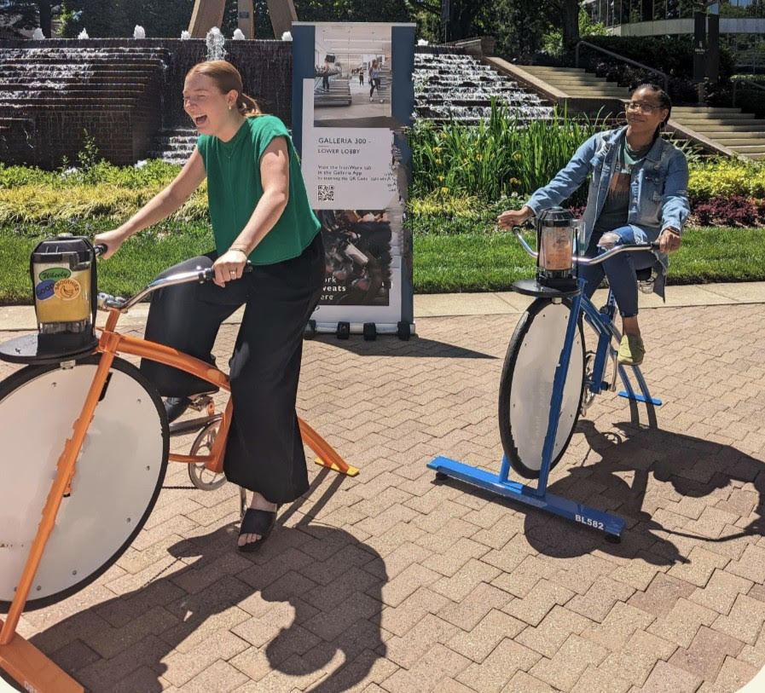

**4. *Ready, Set, Blend***

**Team-building with a twist of health and hype!**  
Perfect for:  
Corporate parties, holiday events, conferences, wellness challenges, and fun fundraisers!

Two options:

* **Option 1:** 100 smoothies + 2 hours of exciting competition
* **Option 2:** 200 smoothies + 3 hours of fast-paced fun

**Package includes:**

* 2 adult smoothie bikes
* Speed monitors + real-time leaderboard
* Energetic host to keep the crowd pumped
* Smoothies made with your own pedal power

Make your event unforgettable with a friendly competition and delicious rewards.

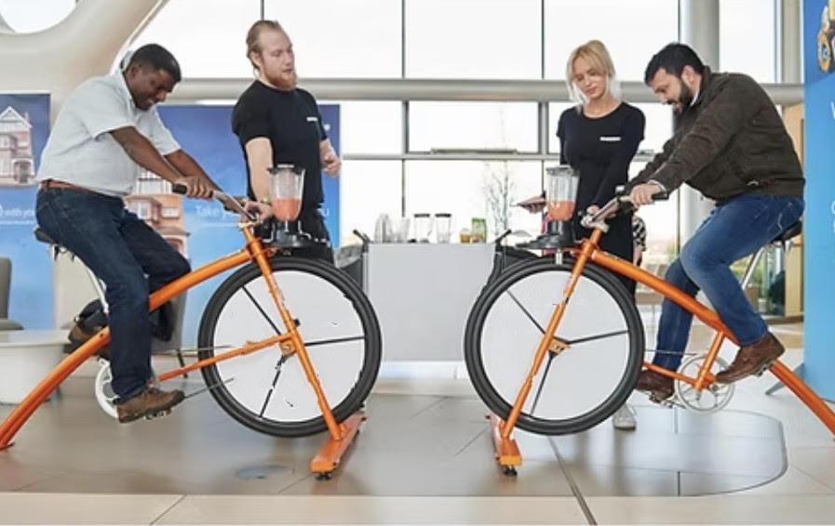

**5. Defi Parent enfant Package**

**A family-powered challenge they won’t forget!**  
Perfect for schools, festivals, family parties, or neighborhood events.

Choose between:

* **Option 1:** 50 smoothies + 2 hours of competition
* **Option 2:** 100 smoothies + 3 hours of energy and fun

**Package includes:**

* 1 kid bike + 1 adult bike
* Speed monitors + live leaderboard
* Lively host & festive energy
* Medal for the winning team

Bonding, laughter, and delicious smoothies — all in one go!

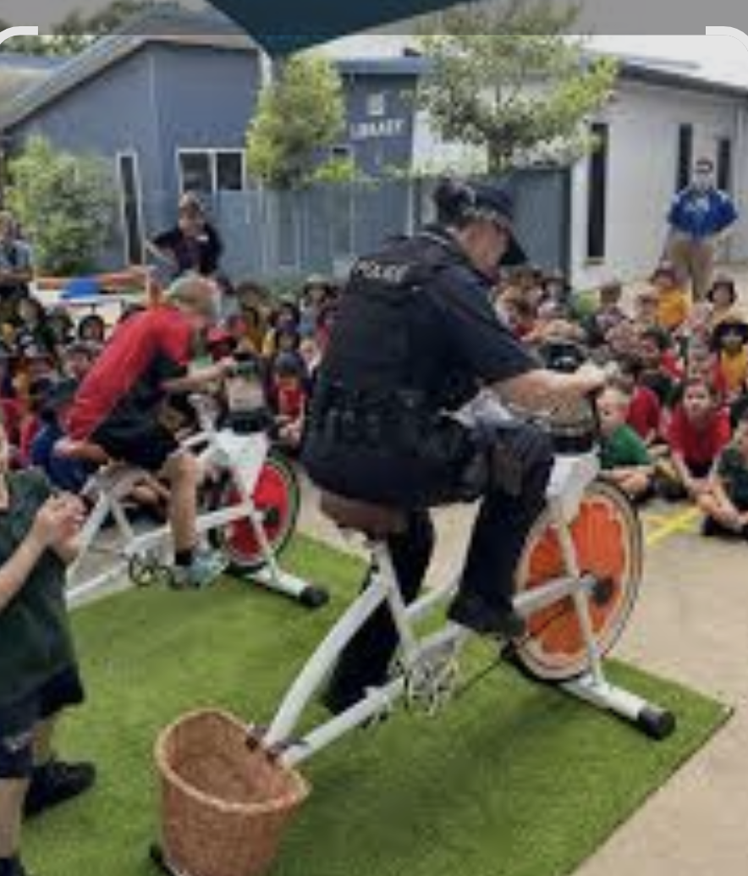

**6. La Smoothie Parade**

Perfect for big crowds and even bigger fun!

This festive package features 2 large blender bikes and 1 small (for kids 6+), perfect for events that call for excitement, color, and community. Let guests pedal their way to delicious smoothies with our interactive setup!

**Package includes:**

* + 3 Blender Bikes (2 Large + 1 Small)
  + 200 Fresh Fruit Smoothies
  + Menu Boards
  + Setup Table

**Ideal For:**

* Corporate Activations
* Festivals & Community Events
* School or University Days
* Shopping Centres
* Team Building & Conferences
* Holiday or Family Celebrations

Bring the energy. Blend the fun.

La Smoothie Parade is your go-to for unforgettable group experiences—indoors or out!

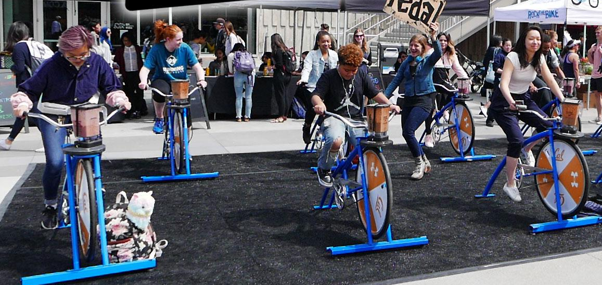

**7- Signature Package**

Add your flavor to the fun!  
Make your event stand out with our Signature Event Branding Package

Turn any event into a unique and memorable experience with Voila Velo!  
Whether it’s a corporate event, brand activation, or a personal celebration, we offer customized branding options to highlight your identity — the smoothie way!

What’s included:

✅ Custom-branded cups  
✅ Double-sided printed wheel covers  
✅ A-frame sandwich boards  
✅ Table decorations in your style

✨ Perfect for all kind of events:

* Corporate events
* Brand awareness campaigns
* School festivals
* Community celebrations
* Weddings, birthdays, and private parties

📩 Get in touch to make your event uniquely yours!

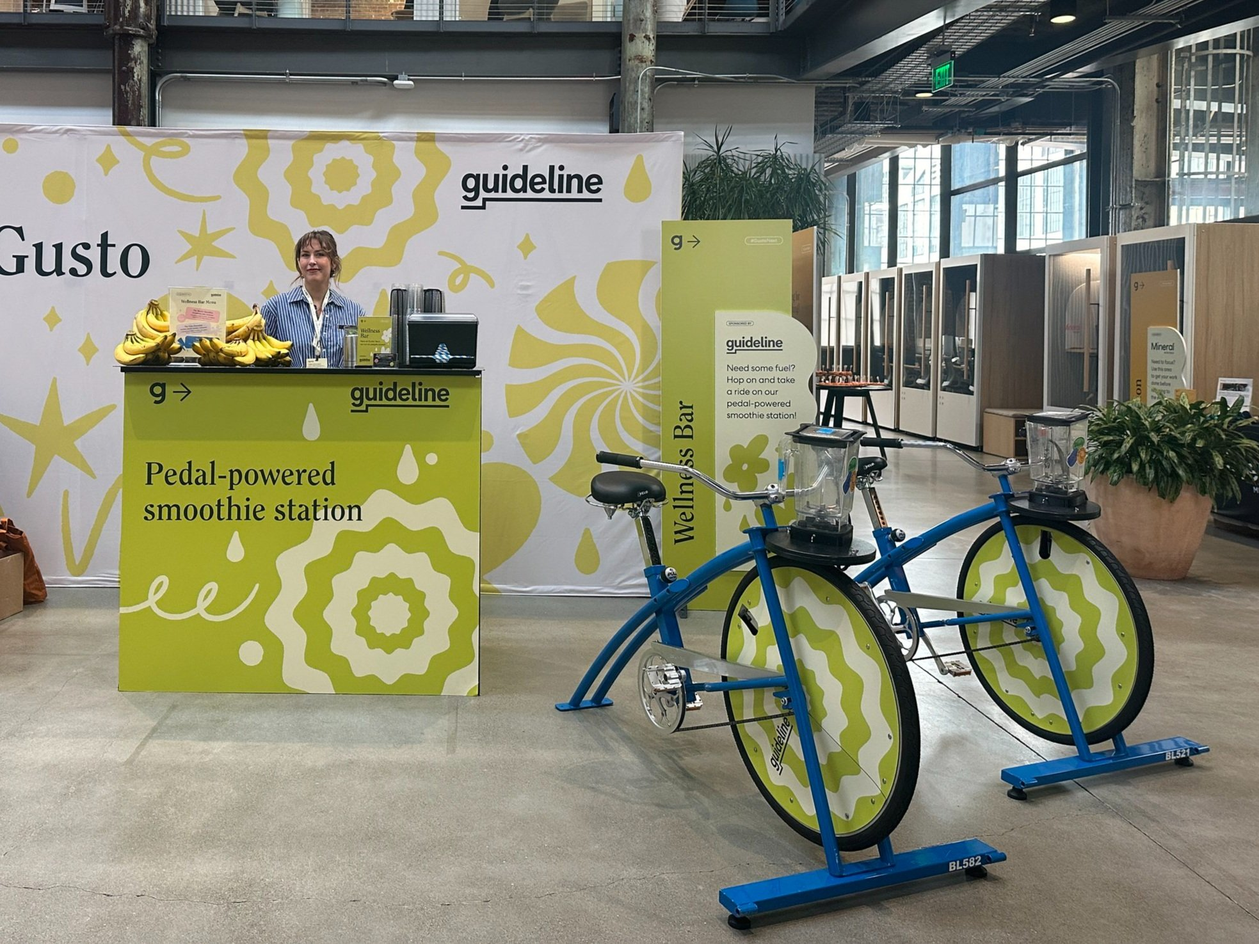

**Events**

we want these 4 categories exactly the same as bikenblend way ( same colours same way of writing  ... Attached pictures are from blendnbike

* + Corporate

Boost employee wellbeing and energize your workplace!

Looking for a fun, healthy, and memorable way to engage your team right at your office! Our smoothie bike setup brings healthy fun directly to your workplace foyer or common area, creating a unique break that your employees will love.

Whether your team is returning to the office or simply needs a boost, our pedal-powered smoothie station is a great way to promote physical activity, nourish the body, and spark conversations.

A healthier employee is not only happier but also more productive—and what better way to promote wellness than with a smoothie they blend themselves?

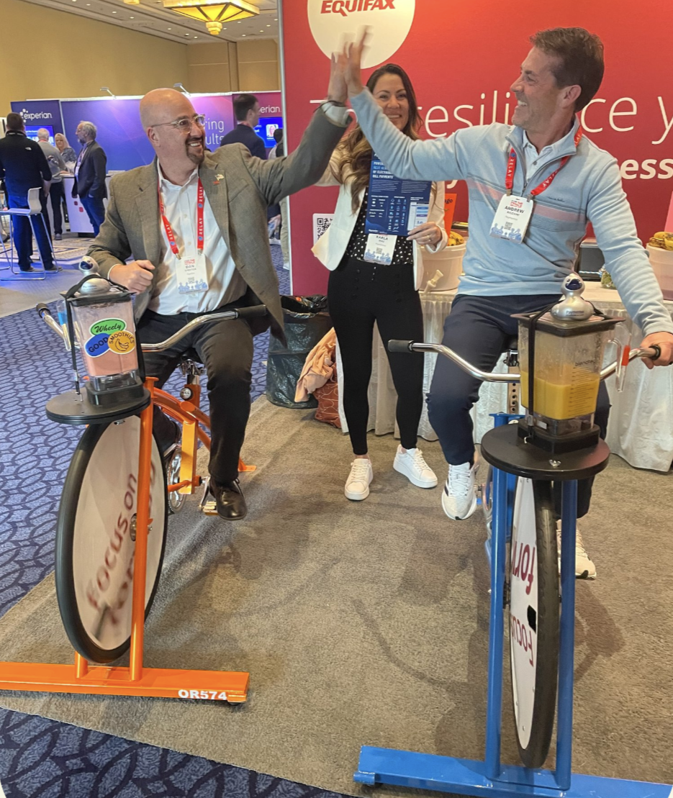

* + Openings & Activations

Make your next event unforgettable—blend your brand into the action!

Want to create a buzz and draw a crowd? Our smoothie bike is more than just a fun activity—it’s a brand magnet. From custom-branded cups to bike wheels, tables, and signage, every element can be tailored with your logo to leave a lasting impression.

As soon as the pedals start spinning, heads turn. It’s a conversation starter, a photo-op, and a feel-good moment all in one. Your team gets the perfect chance to connect, while customers walk away with a smile (and a smoothie!).

In today’s world, experiences build brands. Give people something exciting to talk about—and let them do the marketing for you.

* + Schools, Non-Profits & Birthdays

Bring people together with smoothies, smiles, and a whole lot of fun!

Looking for a creative way to raise funds, connect with your community, or celebrate a special day? Our smoothie bike experiences are perfect for school events, non-profit activations, and even birthday parties!

We offer discounted packages tailored for schools and non-profits, making it easy to deliver an unforgettable event without stretching your budget.

To make planning simple, we include everything you need from A to Z

Let’s blend some fun into your next event!

* + Conferences & Expos

Attract attention, spark conversations, and energize your booth!

Looking for a way to stand out at your next event? Our smoothie bike is a showstopper that gets people pedaling, smiling, and engaging with your brand in a fun and memorable way.

Perfect for indoor or outdoor setups, we offer fully branded stations to match your message and style. Want to turn it up a notch? Add a little friendly competition with our leaderboard and speedometers—it’s a great way to break the ice and draw a crowd.

Make your booth the one everyone remembers.

**Why choose our Voilà Vélo workshop?**

Because it's fun, sustainable, and unforgettable!

At Voilà Vélo, we believe that learning, moving, and enjoying yourself can go hand in hand. Our Smoothie Vélo workshop is more than just an activity — it’s an experience that inspires healthy habits, one pedal-powered smoothie at a time.

🚲 Eco-friendly and energy-free  
No electricity needed! Smoothies are blended by participant pedal power — a zero-emission, 100% human-powered activity that makes sustainability exciting.

🌱 A hands-on approach to sustainability  
Participants become creators, not just consumers. It’s a unique way to understand the impact of our actions, while embracing physical effort and environmental awareness.

🍓 Healthy, tasty, and joyful  
Our smoothies are made on-site with fresh, colorful ingredients and a big dose of fun — combining nutrition and movement for all ages.

🎉 Perfect for all kinds of events  
From schools and festivals to corporate or community events — our workshop adapts to your crowd. It’s inclusive, interactive, and unforgettable.

💚 We pedal for our values  
We use reusable or compostable materials, reduce waste, and promote mindful consumption — all in a lively and welcoming atmosphere.

Voila Velo Frute: Blended by You, Powered by Fun! 🌍💪🍹

**How it Works**

**We cater for events of any size in Montreal, Laval, Quebec city and Ottawa**

**Choose from our popular range of packages or create your own tailored package. All packages include the option of a personalised delivery service to your location.**

[**Contact us for a quote**](https://www.bikenblend.com.au/contact/)

**FAQ**

* + [**How long does it take to make a smoothie?**](https://www.bikenblend.com.au/how-it-works/)

It only takes 30 seconds to pedal a smoothie but you can stay on and keep riding if you wish! It’s loads of fun and very easy for all ages!

* + [**What if I want something on top of what you usually provide?**](https://www.bikenblend.com.au/how-it-works/)

We love to hear interesting ideas! Give us a call or email to discuss the details and we’ll do our best to meet your request.

* + [**What sized bikes do you have?**](https://www.bikenblend.com.au/how-it-works/)

Large bikes (suitable for ages 10 years and up) and small sized blender bikes (suitable for 5-10 year olds) are available. Please specify your requirements when you [make your booking](https://www.bikenblend.com.au/book/).

* + [**Does Voila Velo work better indoors or outdoors?**](https://www.bikenblend.com.au/how-it-works/)

Voila Velo is great for both outdoor or indoor events.

* + [**Can customers make their own drinks?**](https://www.bikenblend.com.au/how-it-works/)

Yes! We encourage all of our customers to blend their own- we think it is more fun and engaging that way. Almost anyone can use the bike blenders- children aged four and above, teenagers, adults, and even sprightly pensioners can comfortably use our awesome bike blenders. Our staff are also keen cyclists if you would like us to lend a hand (or leg) at any time too.

* + **Can we blend alcoholic cocktails at weddings or private parties?**  
    Yes, absolutely! We can blend delicious alcoholic cocktails for weddings and private events. We’ll also take care of obtaining the necessary alcohol permit from Quebec to ensure everything is legal and safe.